Tasks

Objective questions

1. Are there any tables with duplicate or missing null values? If so, how would you handle them?
Ans.
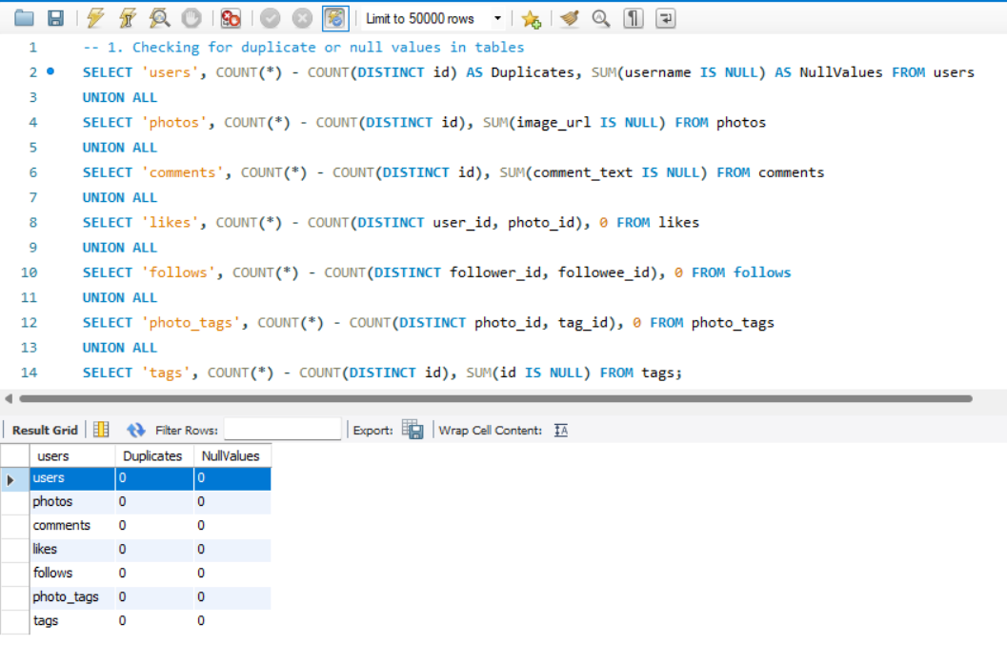
To Identify tables with duplicate or null values, I have used COUNT(*) - COUNT(DISTINCT id) to find duplicates and SUM(column IS NULL) to check null values. Upon reviewing each table, it was confirmed that there are no duplicates or missing NULL values in any of the tables.
This ensures data integrity and correctness before analysis.

2. What is the distribution of user activity levels (e.g., number of posts, likes, comments) across the user base?
Ans.
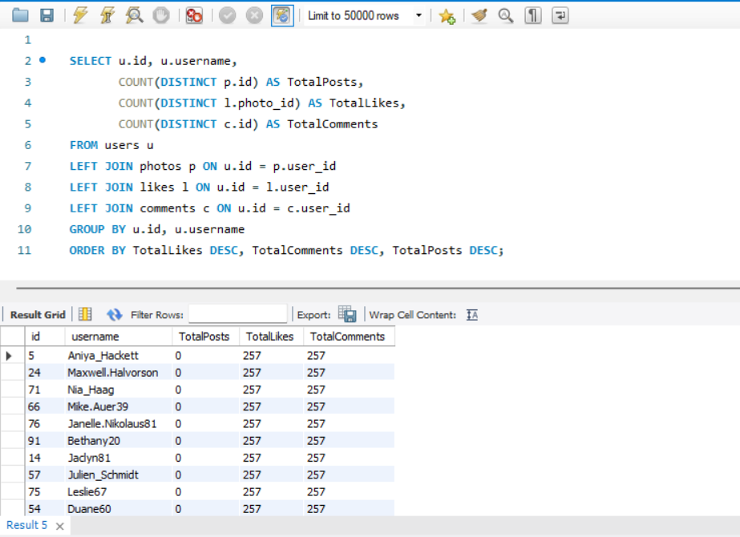 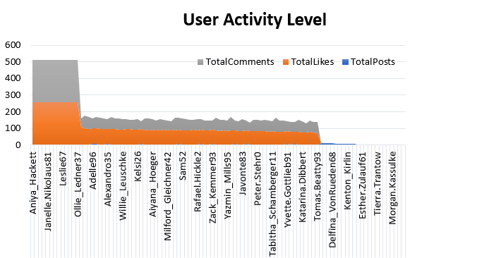
This query counts posts, likes, and comments per user using COUNT(DISTINCT column), including those with no posts, likes, or comments. A "LEFT JOIN" is used to connect the likes, comments, and photos tables with the users table.
This categorizes users based on activity level.
3. Calculate the average number of tags per post (photo_tags and photos tables).
Ans.
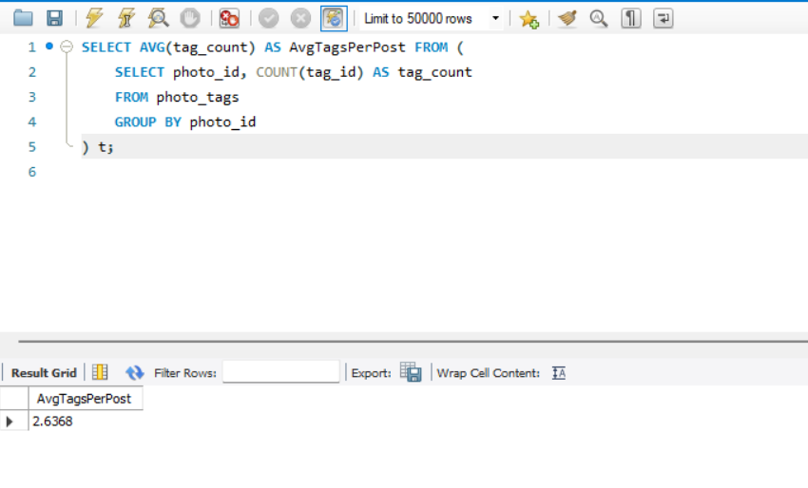
This query first calculates the count of tags for each photo in a subquery and then computes AVG(tag_count) as AvgTagsPerPost.
The calculated average indicates how often users use tags.
4. Identify the top users with the highest engagement rates (likes, comments) on their posts and rank them.
Ans.
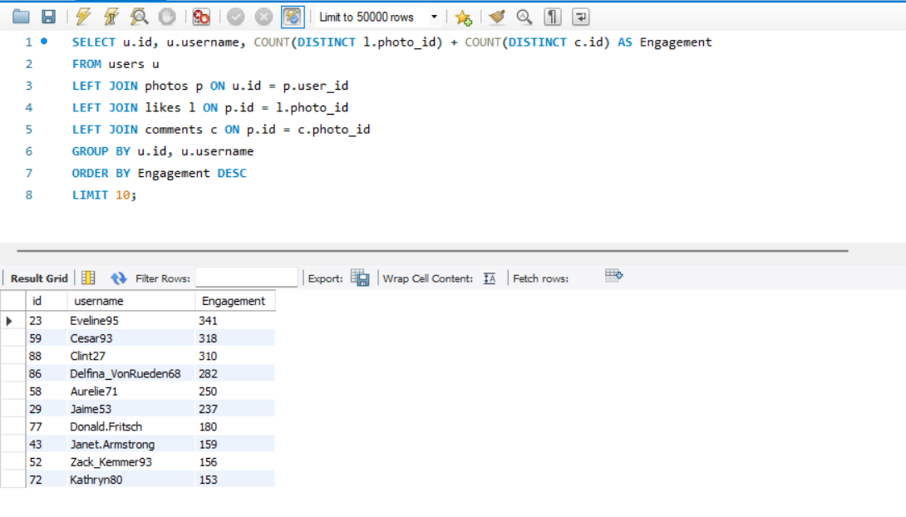
Here, user engagement is calculated by summing likes and comments per user and ranking them using ORDER BY Engagement DESC, considering only users who have posted at least one photo. A "LEFT JOIN" is employed to connect the users table with the other relevant tables.
This identifies the top 10 most engaging users based on likes and comments.

5. Which users have the highest number of followers and followings?
Ans.
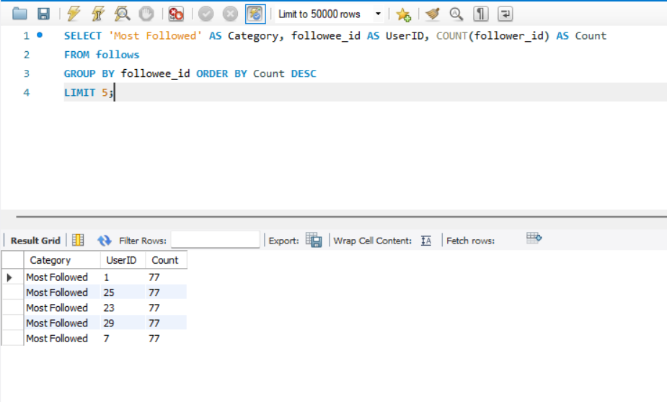
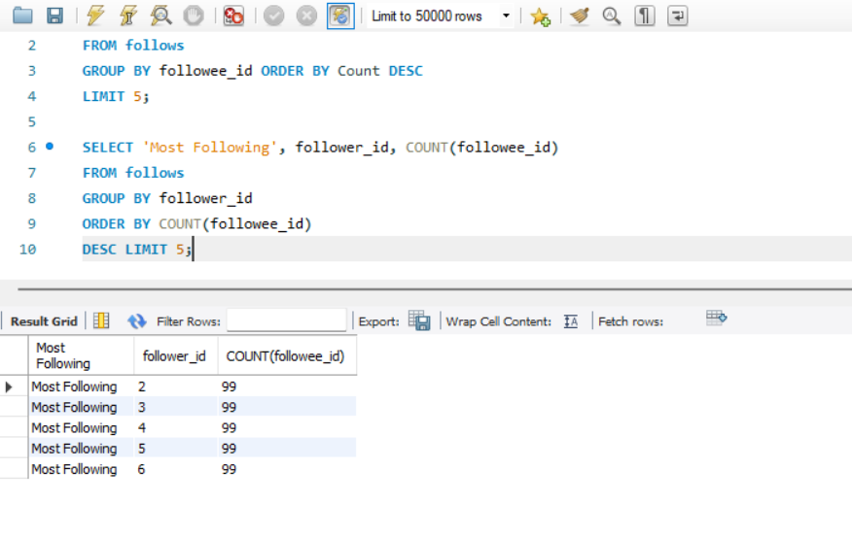
This query retrieves the user's ID, username, and their follower or following count. Used COUNT(follower_id) to find the most-followed and most-following users.
Highlights networking trends. The "LIMIT" clause is used to return only the first user in the specified order.
This provides details of the most-followed and most-following users which helps in understanding user influence and networking trends.
6. Calculate the average engagement rate (likes, comments) per post for each user.
Ans.
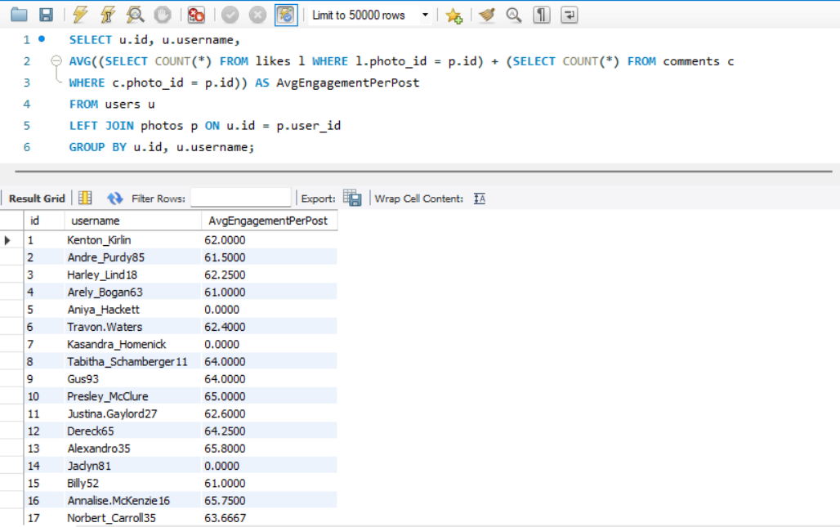
It retrieves the user ID, username, and engagement rate for users who have made at least one post. We used AVG(likes + comments) per post. This shows how well posts are performing on average.
The main purpose is to evaluate content performance.

7. Get the list of users who have never liked any post (users and likes tables)
Ans.
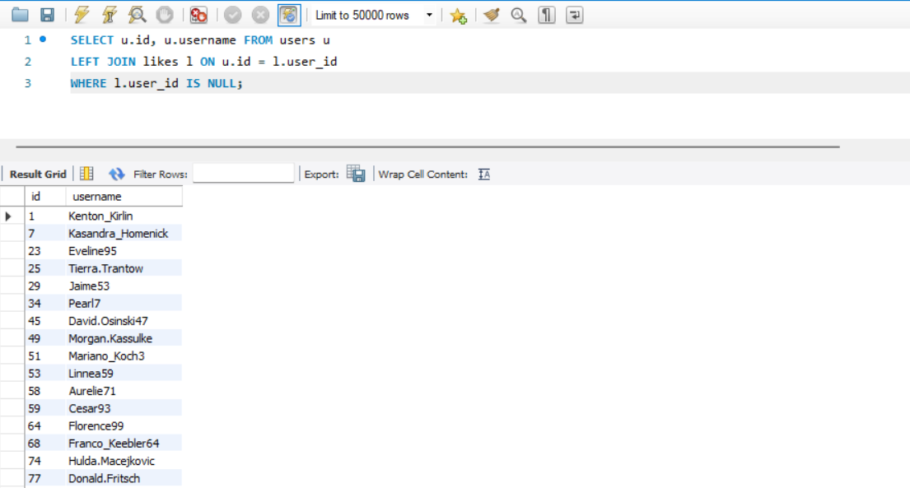
This query retrieves the ID and username of users whose IDs are not present in the likes table. Used LEFT JOIN likes and filtered WHERE l.user_id IS NULL.
This is the list of users who haven’t interacted with posts via likes. This identifies inactive users for engagement strategies.
8. How can you leverage user-generated content (posts, hashtags, photo tags) to create more personalized and engaging ad campaigns?
Ans.
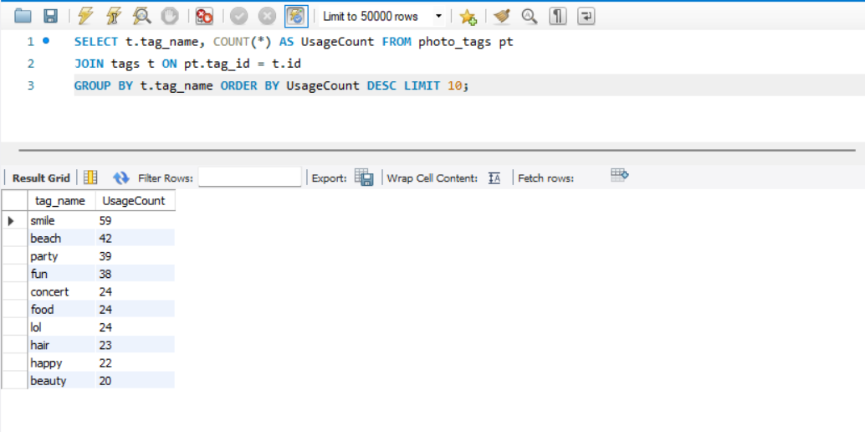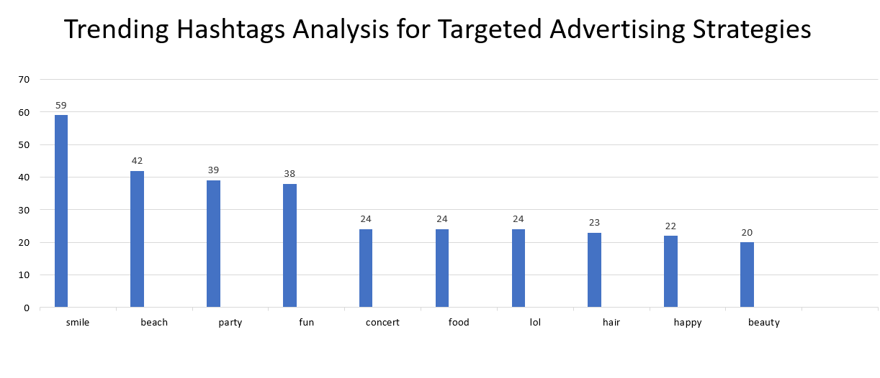
Here, We counted hashtag usage and ranked the top 10 using ORDER BY UsageCount DESC. That is the top 10 hashtags based on usage count. Basically, this query calculates the average number of likes for photos associated with each tag. It starts by determining the total likes per photo and then averages these totals across all photos linked to each tag. The results are grouped by tag name and sorted in descending order of average likes. Finally, the top 10 tags with the highest average likes are selected and displayed.
This helps in targeted advertising.

9. Are there any correlations between user activity levels and specific content types (e.g., photos, videos, reels)? How can this information guide content creation and curation strategies?
Ans.
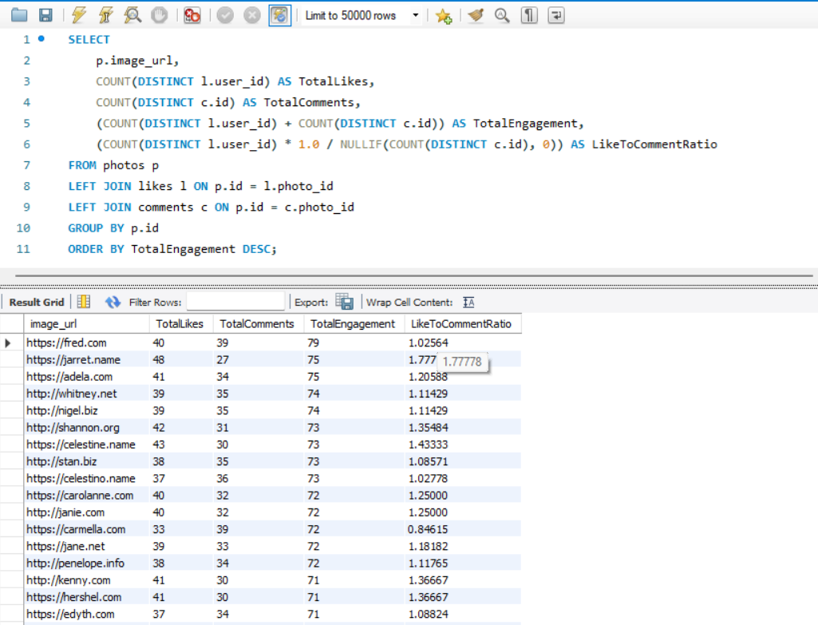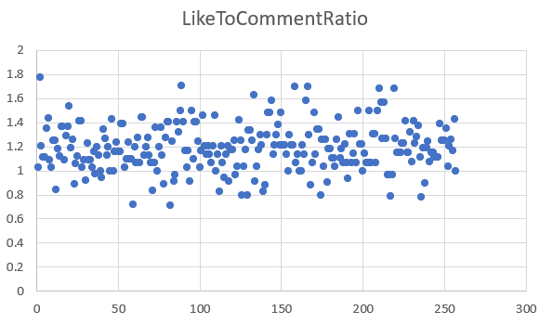
First we have counted likes and comments for each image and created a Total Engagement metric (likes + comments). Then Added a Like-to-Comment Ratio (Likes / Comments) to measure user interaction trends and Ordered results by Total Engagement DESC to find the most engaging content. This Identifies the most liked and commented images.
So, there is no correlation between user activity levels and specific content types. This Helps content creators optimize post types for maximum engagement and Businesses can target highly interactive content for promotions.
Users tend to focus on one type of engagement, either commenting or posting photos. The majority prefer photos as their primary content type, making photo-sharing a significant driver of user engagement on the platform.

10. Calculate the total number of likes, comments, and photo tags for each user.
Ans.
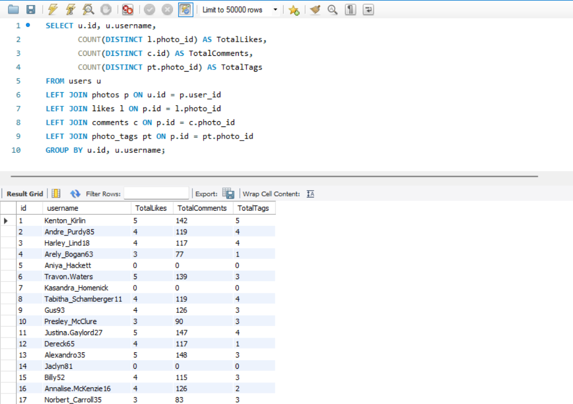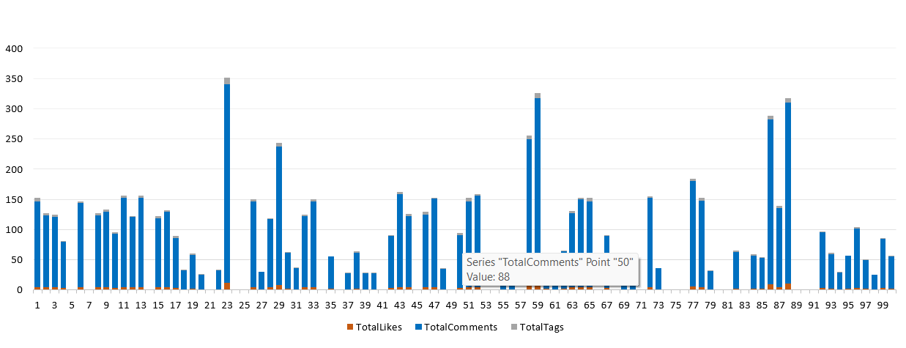
This query COUNT(DISTINCT column) aggregates the total likes, comments, and photo tags for each user on the platform, combining these figures with user details. It ensures that users with no activity are still represented, with their counts set to zero

11. Rank users based on their total engagement (likes, comments, shares) over a month.
Ans.
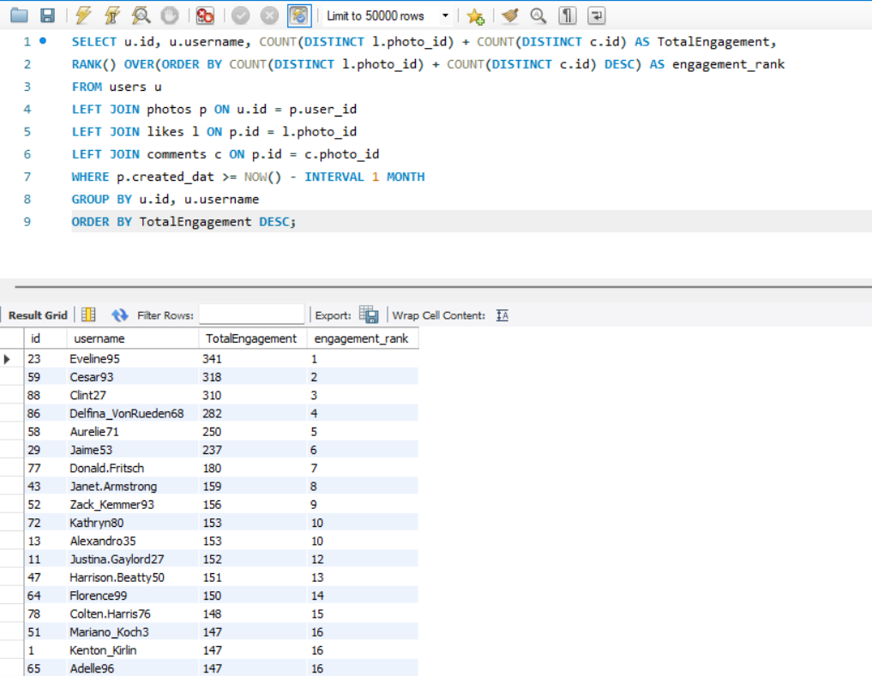
This query calculates and ranks user engagement for the past month by aggregating the total likes, comments, and tags associated with each user's photos. It sums these values to determine a total engagement score and ranks users accordingly, with the highest engagement ranked first. The output includes each user's ID, username, total engagement and their engagement rank.
This helps track user retention and engagement trends.

12. Retrieve the hashtags that have been used in posts with the highest average number of likes. Use a CTE to calculate the average likes for each hashtag first.
Ans.
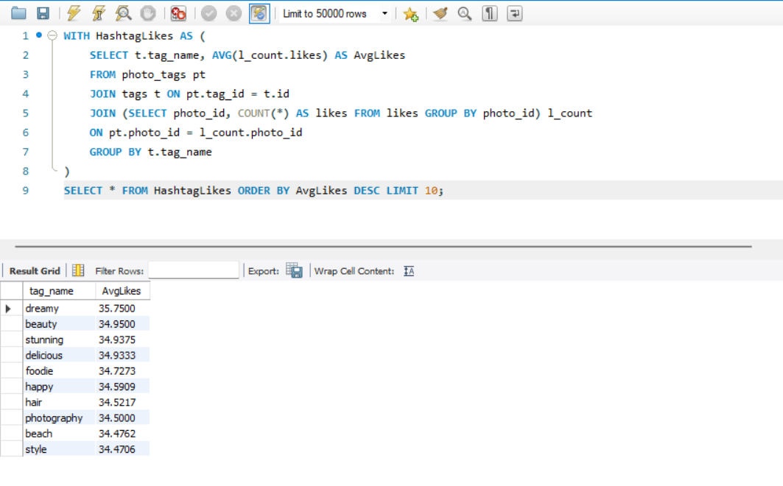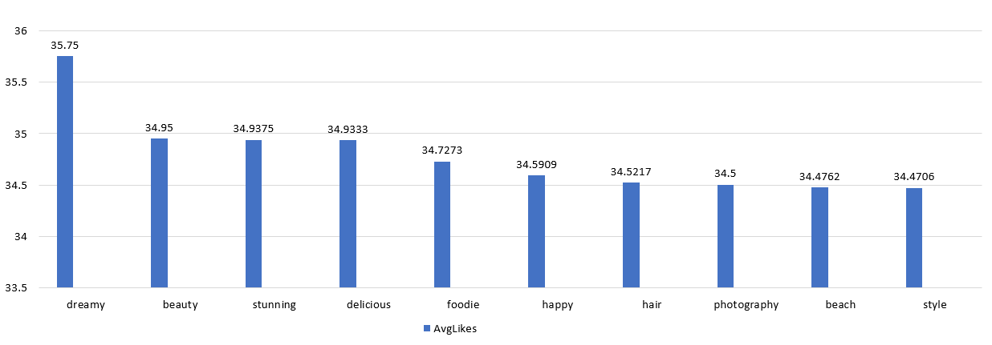
This query calculates the average likes for photos associated with each tag. It begins by summing the likes for each photo and then averages these totals across all photos linked to each tag, where we use AVG(likes) for each hashtag. The results are grouped by tag name and sorted by average likes in descending order. Finally, the top 10 tags with the highest average likes are displayed.
This finds the most engaging hashtags.

13. Retrieve the users who have started following someone after being followed by that person.
Ans.
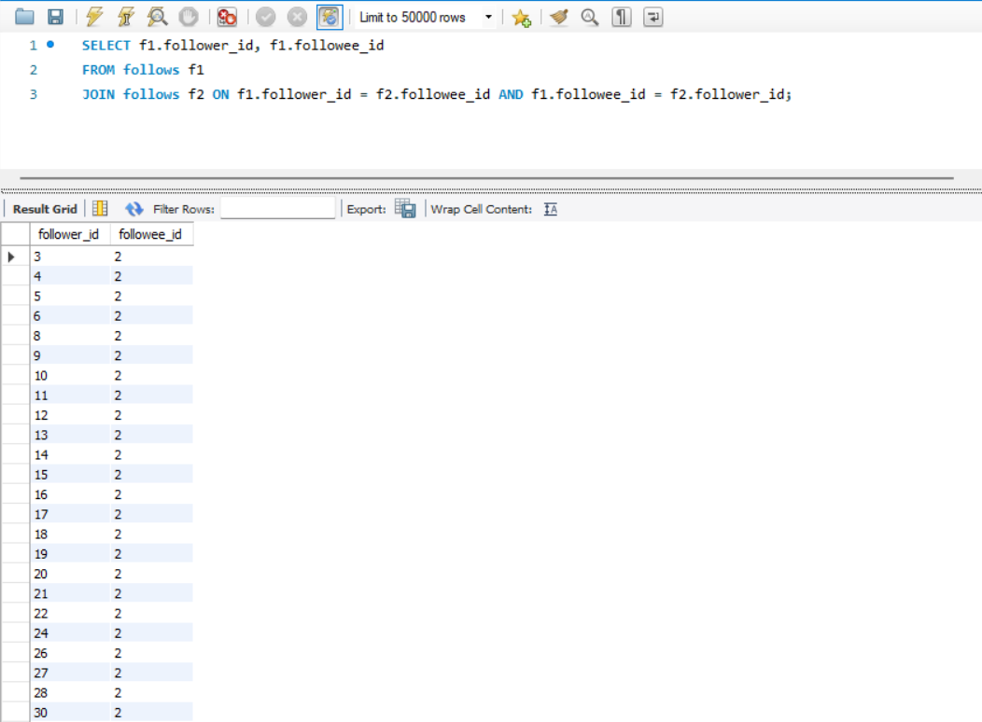
This query identifies pairs of users who follow each other, where one user followed the other first. It matches users based on their follow relationships and used JOIN follows to match mutual follows.
It is useful for social behaviour analysis and community building and analyze follow-back behaviour.

Subjective Question
1. Based on user engagement and activity levels, which users would you consider the most loyal or valuable? How would you reward or incentivize these users?
Ans.
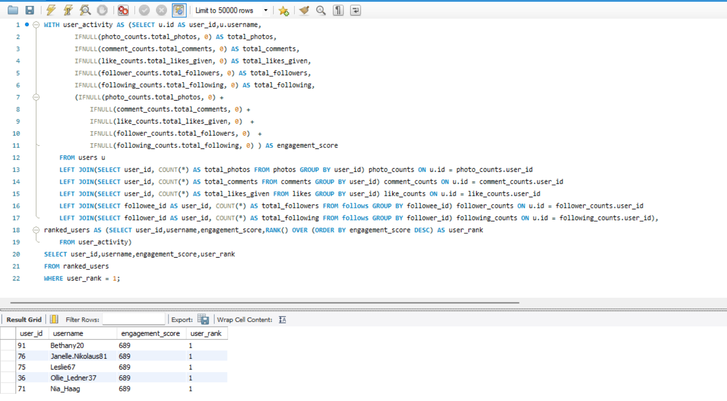
Approach: This query evaluates and ranks users based on their overall engagement on the platform. It combines several activity metrics, such as the number of photos posted, comments made, likes given, followers, and following count, to compute an engagement_score for each user. Users are ranked in descending order of their engagement score. The output includes the user ID, username, engagement score, and rank, showing only the top-ranked user with the highest engagement score.
Insight: The most loyal and valuable users are: Aniya_Hackett, Duane60, Mckenna17, Mike.Auer39, Jaclyn81, Rocio33, Julien_Schmidt, Maxwell.Halvorson, Bethany20, Janelle.Nikolaus81, Leslie67, Ollie_Ledner37, and Nia_Haag.
Recommendation: Reward & Incentive Ideas
- Gift Cards & Discounts: Tangible perks that boost engagement.
- Exclusive Features: Access to analytics or tools that enhance user growth.
- Event Invitations: Strengthen community ties and networking.
- Custom Badges/Titles: Recognize contributions and elevate visibility.

2. For inactive users, what strategies would you recommend to re-engage them and encourage them to start posting or engaging again?
Ans.
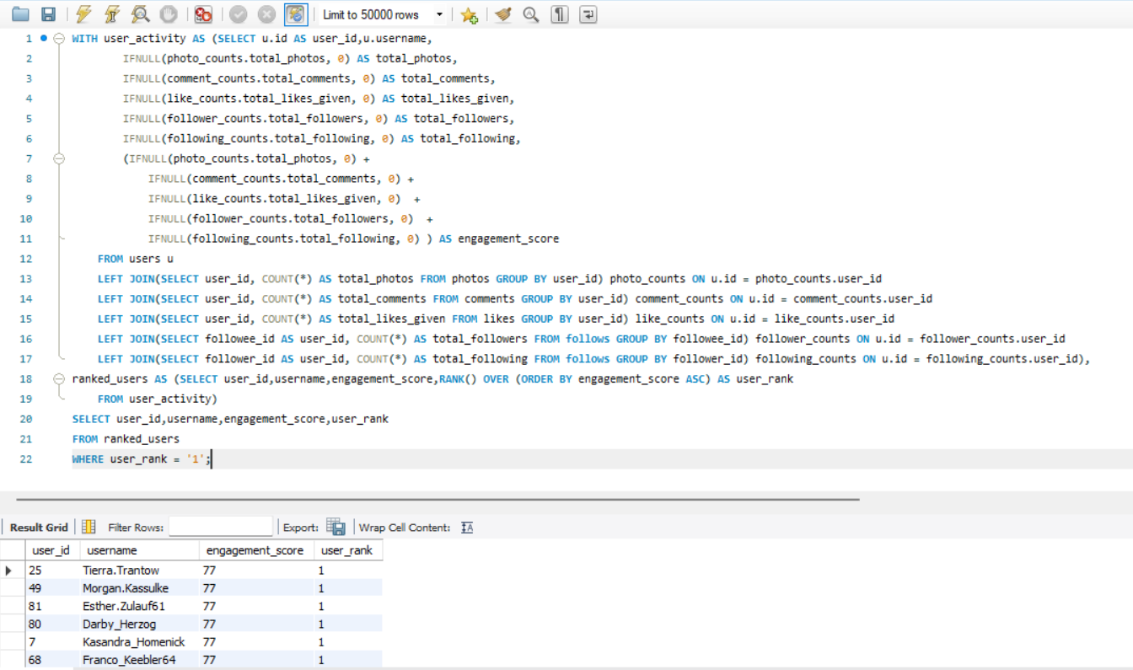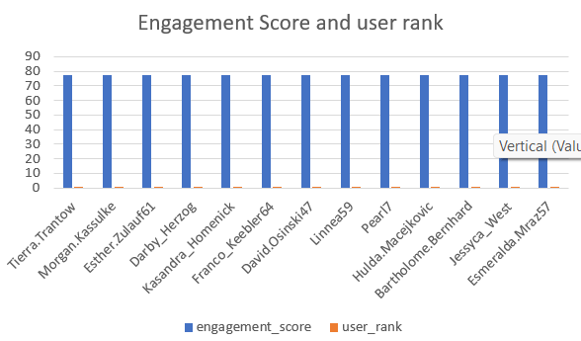
Approach: This query evaluates and ranks users based on their minimal engagement on the platform. It aggregates various activity metrics, including the number of photos, comments, likes given, followers, and following, into an engagement_score. Users are ranked in ascending order, with the user having the lowest engagement score ranked highest. The output displays the user ID, username, engagement score, and rank, focusing on the user with the lowest engagement score.
Recommendation: User Engagement & Re-Engagement Strategy
- Engagement Score: Based on uploads, comments, likes, followers, and following.
- Rewards for Active Users
- Gift cards, discounts, and exclusive features
- Custom badges, titles, and event invitations
- Re-Engagement Tactics for Inactive Users
- Personalized outreach with missed updates and tailored suggestions
- Milestone reminders and gamified challenges
- Content prompts, re-onboarding walkthroughs, and themed campaigns
- Feedback surveys and improved content discovery

3. Which hashtags or content topics have the highest engagement rates? How can this information guide content strategy and ad campaigns?
Ans.
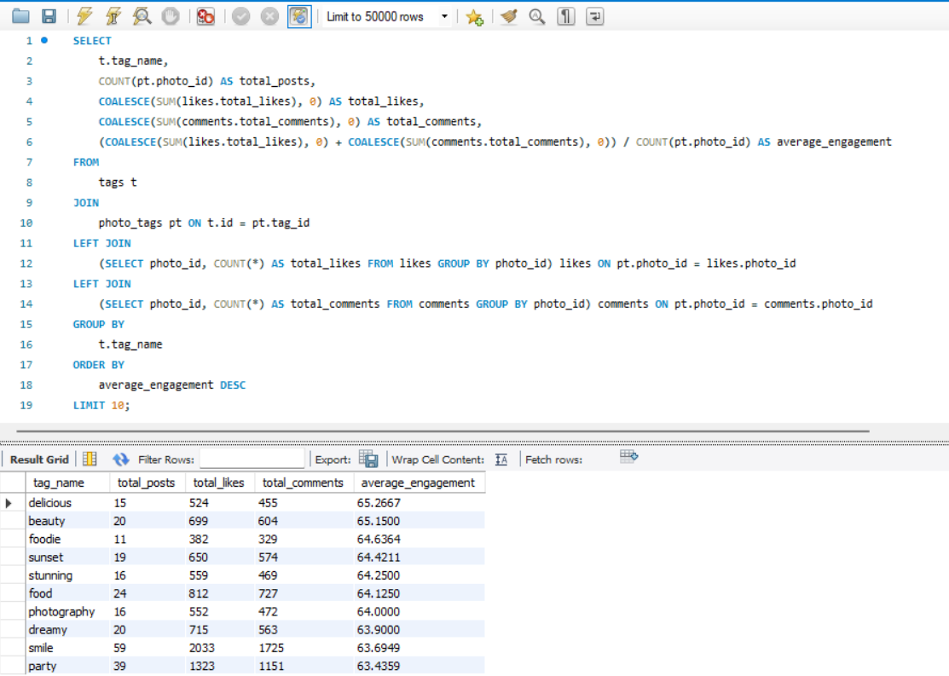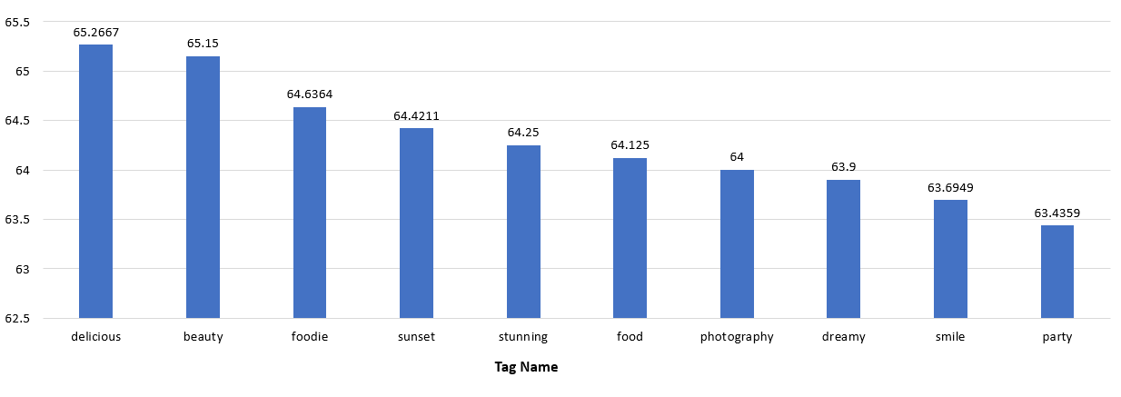
Approach : This query identifies the top 10 tags with the highest average engagement on the platform. It computes the total posts, likes, and comments for each tag, then calculates the average engagement per post. The results are sorted in descending order of average engagement.
Insight: The hashtags with the highest engagement rates are: delicious, beauty, foodie, sunset, stunning, food, photography, dreamy, smile, and party.
Recommendation: Hashtag-Driven Engagement Strategy
Content Creation & Curation
-Focus on high-engagement themes like food (#foodie, #delicious), beauty (#beauty, #stunning), and photography (#sunset, #photography). Launch campaigns inviting users to share content using these hashtags.
Ad Targeting & Campaigns
- Use hashtags in ad copy and visuals to align with lifestyle themes
- Partner with influencers who drive engagement in these categories
- Target users who interact with related hashtag content
Engagement Optimization
- Run recurring series (e.g., weekly #sunset posts)
- Cross-promote across platforms to boost visibility
- Post at optimal times (e.g., #sunset in the evening)
Content Discovery & Algorithm Boost
- Use trending hashtags to improve reach and Explore page visibility
- Personalize content recommendations based on hashtag insights

4. Are there any patterns or trends in user engagement based on demographics (age, location, gender) or posting times? How can these insights inform targeted marketing campaigns?
Ans.
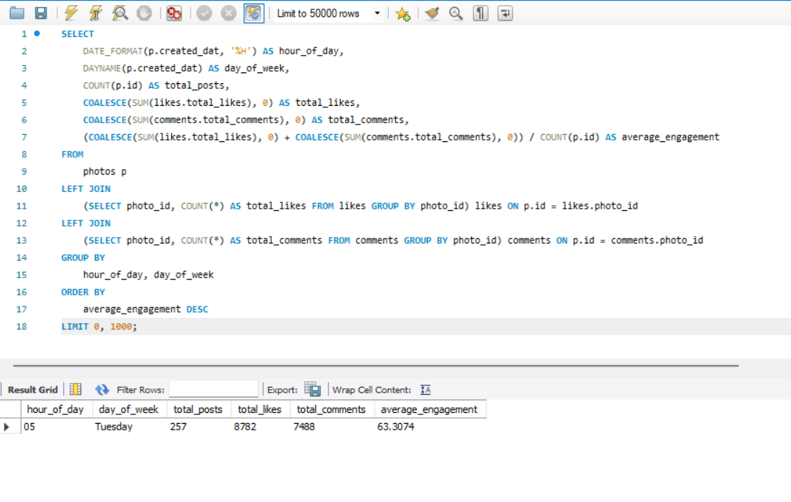
Approach : This query analyzes photo engagement based on the hour of the day and day of the week. It groups photos by the hour they were posted, counting the total number of posts, likes, and comments for each hour. The average engagement per post (calculated as likes plus comments divided by the number of posts) is then computed and the results are sorted in descending order by this average engagement.
Key Engagement Insights & How to Use Them
- Best Time to Post: Engagement peaks at 12 AM on Thursdays—a great time for ads and important content.
- User Activity Snapshot: Around 100 users posting at 10 AM on Tuesdays generated strong results: 257 posts, 8,782 likes, and 7,488 comments.
- Content Timing Tips: Evening posts with hashtags like #sunset, #evening, #photography perform better because they match the mood and time of day.
-Audience Preferences: Age and gender affect what people engage with—so tailor content to match different groups

5. Based on follower counts and engagement rates, which users would be ideal candidates for influencer marketing campaigns? How would you approach and collaborate with these influencers?
Ans.
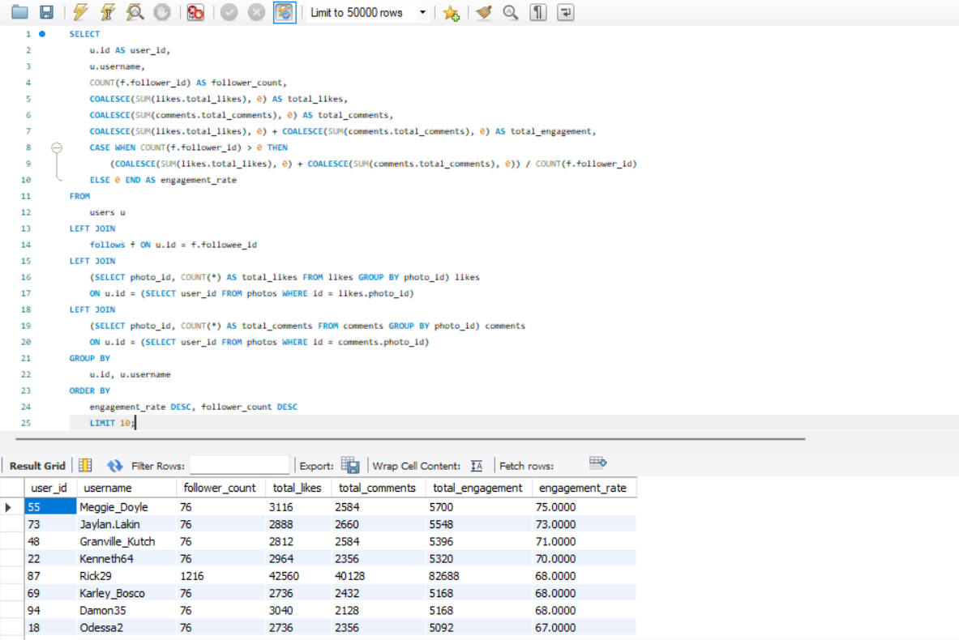
Approach: This query ranks users based on their engagement rate. It calculates each user's follower count and aggregates the total likes and comments on their photos. The engagement rate is determined by dividing the total engagement by the number of followers, with a special condition to handle cases where users have no followers. The results are sorted in descending order of engagement rate, with ties resolved based on follower count. The query returns the top 10 users with the highest engagement rates, including their user ID, username, follower count, total likes, total comments, total engagement, and engagement rate.
Recommendation: Approaching and Collaborating with Influencers:
- Check if the influencer’s content and audience match your brand.
- Mention specific posts when reaching out to make it personal.
- Set clear goals for the campaign.
- Give influencers creative freedom within your brand guidelines.
- Pay them or send product gifts.
- Consider long-term partnerships for ongoing impact.
- Use clear metrics (likes, shares, reach) to measure success.
- Share their content on your own channels to boost visibility.

6. Based on user behaviour and engagement data, how would you segment the user base for targeted marketing campaigns or personalized recommendations?
Ans.
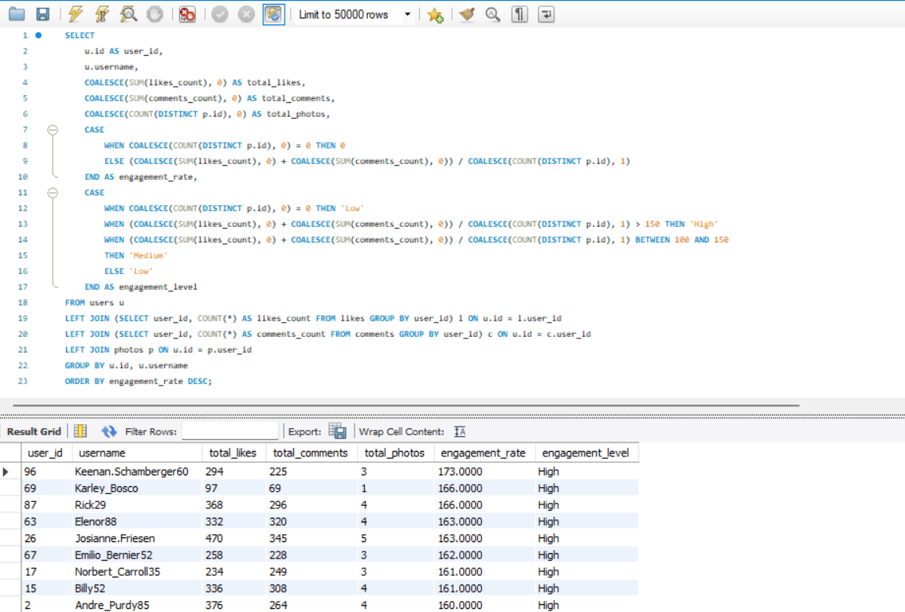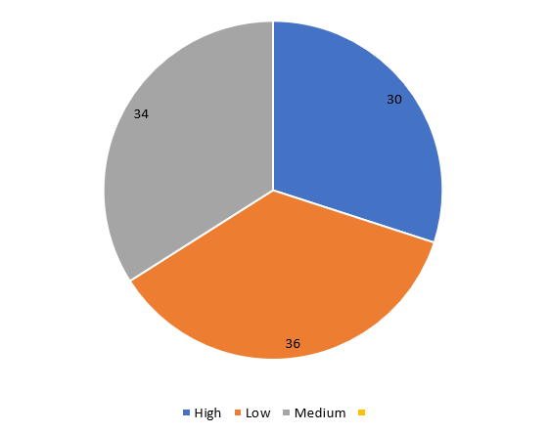
Approach : This SQL query analyzes and categorizes user engagement on the platform. It begins by retrieving user details, such as user_id and username, from the users table. By joining the likes and comments tables, it aggregates the total likes and comments for each user. Additionally, it calculates the number of photos each user has posted by referencing the photos table.
● The engagement rate is computed as the total likes and comments divided by the number of photos.
● Users are then classified into engagement levels- 'High,' 'Medium,' or 'Low’ based on their engagement.
The query groups data by user, organizes the results by engagement rate in descending order, and provides valuable insights into user activity, enabling the identification of varying levels of engagement among users.

Strategies for Targeted Marketing and Personalized Recommendations:
High Engagement Users (30%)
- Marketing: Reward loyalty with early access and exclusive offers.
- Recommendations: Suggest similar content/products they already love. Personalize updates based on their habits.
Medium Engagement Users (34%)
- Marketing: Use promotions and interactive ads to boost activity.
- Recommendations: Mix familiar items with trending ones to spark interest.
Low Engagement Users (36%)
- Marketing: Re-engage with discounts, reminders, and helpful content.
- Recommendations: Show popular or curated suggestions to grab attention.
How to Execute
- Analyze Data: Track user behavior to keep segments up to date.
- Custom Messaging: Send tailored offers and updates to each group.
- A/B Testing: Try different tactics to see what works best.
- Monitor & Improve: Review campaign results and adjust strategies accordingly.

7. If data on ad campaigns (impressions, clicks, conversions) is available, how would you measure their effectiveness and optimize future campaigns?
Approach: Measuring Campaign Effectiveness
Key Performance Indicators (KPIs)
- Impressions: Track how many times your ad is shown. High impressions with low engagement may indicate poor audience targeting.
- Click-Through Rate (CTR): Calculated as clicks ÷ impressions. A low CTR suggests the ad’s design, copy, or targeting needs improvement.
- Conversion Rate: Percentage of clicks that result in a desired action (purchase, signup, etc.). This measures the ad’s effectiveness in driving results.
Return on Ad Spend (ROAS)
- ROAS: Revenue ÷ ad cost. A higher ROAS means a more profitable campaign.
- Customer Acquisition Cost (CAC): The cost of gaining one new customer. Compare with Customer Lifetime Value (CLV) to assess long-term profitability.
Impression Share
- Measures the percentage of total available impressions captured by your ad.
- Helps evaluate visibility and benchmark against competitors.
Bounce Rate
- Percentage of users who click an ad but leave the landing page immediately.
- A high bounce rate may signal a disconnect between the ad and landing page. Optimize content and design for relevance and engagement.

Recommendation : Optimizing Future Campaigns
Ad Creative
- Refresh ad creatives regularly to avoid fatigue.
- Use insights from top-performing ads to guide future content and messaging.
Budget Allocation
- Shift budget toward channels, campaigns, or audiences with the best ROAS.
- Test bidding strategies (manual vs. automated) to maximize efficiency.
Frequency Capping
- Limit how often a user sees your ad to prevent fatigue.
- Experiment with different caps to balance reach and engagement.
Landing Page Optimization
- Improve user experience with fast load times, clear CTAs, and mobile-friendly design.
- Ensure landing page content matches ad messaging to improve conversions.
Cross-Channel Attribution
- Apply attribution models (first-click, last-click, linear, etc.) to understand each channel’s role in conversions.
- Reinvest in channels that drive the strongest results across the customer journey.

8. How can you use user activity data to identify potential brand ambassadors or advocates who could help promote Instagram's initiatives or events?
Approach:
High Engagement Users: Seek individuals who consistently interact with content (likes, comments, shares) and maintain influence within specific niches or communities.
- Content Creators: Focus on users who produce original, high-quality content that aligns with the brand’s values and tone.
- Positive Sentiment: Use sentiment analysis to identify users who frequently express positive feedback about the brand and its features.
- Frequent Interactions: Monitor users who actively engage with the brand’s official account or frequently discuss the brand on other platforms.
Recommendations:
Outreach Strategy
- Personalized Approach: Craft tailored messages highlighting their influence and how their values align with brand initiatives.
- Value Proposition: Provide meaningful incentives such as early access to features, exclusive experiences, or campaign rewards.
Collaboration Framework
- Clear Expectations: Define campaign goals, deliverables, and content guidelines from the start.
- Creative Freedom: Allow ambassadors to create in their own voice and style to preserve authenticity.
- Long-Term Partnerships: Develop lasting relationships with high-performing ambassadors to support ongoing campaigns and events.

9. How would you approach this problem, if the objective and subjective questions weren't given?
Approach
1. Data Exploration & Analysis
- Understand the Dataset: Begin with a thorough review of the available data. While the sample of 100 users is limited, it still offers valuable insights into user behaviors and trends.
- Identify Data Gaps: Note limitations early to frame realistic conclusions and highlight areas where additional data could strengthen analysis.
2. Key Metrics to Track
- Engagement Metrics: Evaluate user activity through likes, comments, tags, and photo uploads. Cross-reference with follower/following counts to identify potential creators and emerging influencers.
- Retention Metrics: Assess user activity over different time frames (weekly, monthly, yearly). Identify consistently active users as well as inactive ones to inform re-engagement strategies.
- Acquisition Metrics: Track new user growth and measure how high-engagement users contribute to attracting and retaining newcomers.
3. User Segmentation & Targeted Strategies
- Segmentation by Engagement: Classify users into groups (highly active, moderately active, inactive). Highlight those with both reach (large following) and strong interaction rates for ambassador programs.
- Personalized Content Delivery: Use segmentation insights to tailor messaging. For example, re-engagement efforts for inactive users could include in-app nudges, reminders, or personalized recommendations.
4. Trend Analysis & Engagement Drivers
- Hashtag Insights: Identify trending hashtags and analyze which generate the most interaction. This reveals key interests and conversation topics that keep users engaged.
- Influencer Mapping: Link trends to potential influencers who naturally drive engagement within specific communities.
- Predictive Modeling: Build models to anticipate churn, identify potential brand advocates, and forecast content performance.
- Campaign Example: If hashtags like #smile trend highly, launch themed campaigns (e.g., #BeautyInASmile) to encourage positive, shareable content and expand reach with aligned tags like #PositiveVibes and #Happiness.
5. Feedback & Continuous Improvement
- User Behavior Insights: Use clickstream and browsing data to refine understanding of user preferences.
- Campaign Evaluation: Gather feedback on past campaigns to measure impact and refine strategies.
- Ongoing Optimization: Integrate learnings continuously to enhance campaign design, messaging, and targeting.

10. Assuming there's a "User_Interactions" table tracking user engagements, how can you update the "Engagement_Type" column to change all instances of "Like" to "Heart" to align with Instagram's terminology?
Ans. Query
UPDATE User_Interactions
SET Engagement_Type = 'Heart'
WHERE Engagement_Type = 'Like';

Steps to Implement
- Data Validation
  - Confirm that "Like" is the only existing value used for this engagement type.
  - Check for case sensitivity or alternative variations (e.g., like, LIKE) to ensure a complete update.
- Execute the Update
  - Apply the SQL update to replace "Like" with "Heart" in the Engagement_Type column.
  - Run the query within a controlled batch or use transaction management to allow rollback if needed.
- Testing & Quality Assurance
  - Test the change in a staging environment before deployment.
  - Verify that reporting, analytics, and user-facing features continue to function correctly.
- User Communication
  - Notify users of the terminology update through in-app notifications, release notes, or announcements.
  - Provide a clear explanation of the change and its purpose to ensure transparency.
- Post-Implementation Monitoring
  - Track system performance and user interactions after rollout.
  - Monitor adoption, user sentiment, and engagement metrics to confirm the update’s success.

